GREATEST OF TWOS NUMBERS:

AIM:TO PERFORM A PROGRAM GREATEST OF TWOS NUMBERS USING 8085 PROCESSOR

ALGORITHM:

1. Step 1: Start.
2. Step 2: Read a, b . / \* a, b two numbers \*/
3. Step 3: If a>b then /\*Checking \*/
4. Display “a is the largest number”.
5. Otherwise.
6. Display “b is the largest number”.

PROGRAM:

LDA 2050

MOV B,A

CMP B

JNC STORE

MOV A,B

STORE:STA 2052

HLT

INPUT:

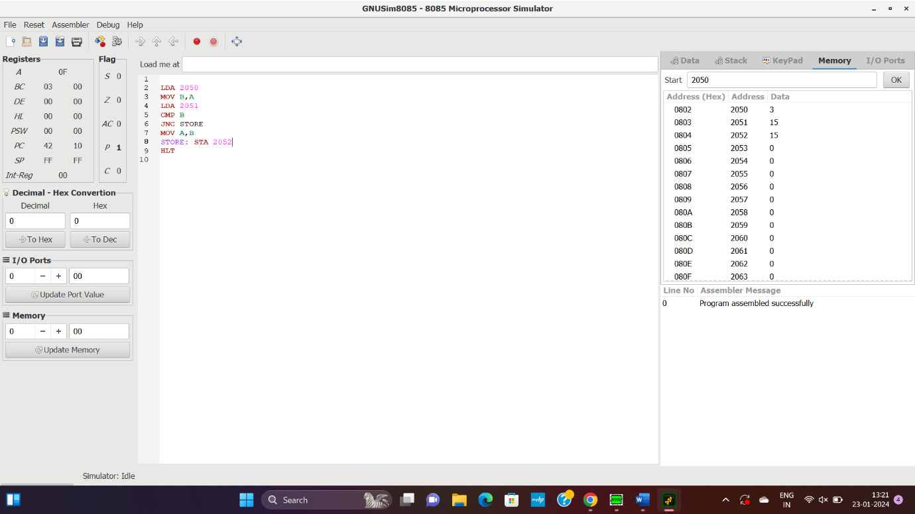

OUTPUT:



RESULT: THUS THE PROGRAM WAS EXECUTED SUCESSFULLY.